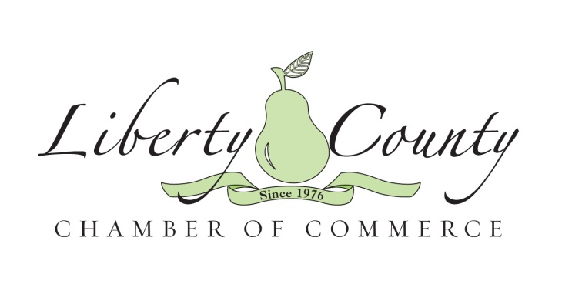

TASTE OF LIBERTY RULES & REGULATIONS

The 2020 Taste of Liberty is a one-night event combined with the Liberty County Chamber of Commerce’s Annual Banquet and will feature local restaurants and businesses sampling their best dishes and a wine pull. Hosted by the Liberty County Chamber of Commerce on Thursday, January 16, 2020, the Taste of Liberty will welcome over 150 food enthusiasts and members of the local business community to experience the best that Liberty County has to offer.

DATE | Thursday, January 16, 2020
LOCATION | The historic Bacon Fraser House, 208 E Court Street, Hinesville
APPLICATION DEADLINE | January 7, 2020
SET-UP TIME | 3-5pm
EVENT HOURS | Cocktail Hour is at 5:00pm  Food Service is at 6:00pm

APPLICATION PROCESS
Businesses may apply to the 2020 Taste of Liberty by submitting the 2020 Taste of Liberty Application to the Liberty County Chamber of Commerce at director@libertycounty.org. Applications will be accepted from now until January 7, 2020. There is limited space available. Food vendor applications must be filled out entirely and accompanied with the following information: digital copy of your logo and a $50 refundable deposit*.

EXPECTATIONS
The 2020 Taste of Liberty is an opportunity for individual businesses to sample items that make their menus interesting and unique. This is a great time to not only expose your business to a large group of potential customers, but it is also a perfect occasion to demonstrate to the local business community and attendees the other services your business provides (various catering options, your breakfast menu, corporate lunches, unique local faire, your tablescape talents, etc.).
Samples should be approximately 2-3 bites in size and it is recommended that each business prepare at least 200 pieces. Patrons are coming to this event to experience a variety of offerings. We are making the assumption that each attendee will experience each business at least once. Because there is no way to know for sure how the crowd will act, the sample expectations are only recommendations. Other factors such as the popularity of the dish, the uniqueness of the dish, and table placement must be considered by each business.
The Liberty County Chamber of Commerce is not responsible for businesses who over prep or run out of samples early. We will do our best to provide useful information in a timely manner in order to help each business make educated decisions about the event. However, in the end, each business participating is an independent business and is solely responsible for the menu choices, food cost, piece numbers and any other business related decisions regarding their business as it relates to the event. There will be limited electricity provided, so please plan accordingly.

SPACE OPTIONS

DEPOSIT AMOUNT | WHAT’S INCLUDED
$50.00*  *Deposit is refunded provided that the business participates in the event and in the event of a cancellation, 48 hours cancellation notice is provided in writing per the Liberty County Chamber of Commerce’s Cancellation Policy. | - One 6 foot table and two chairs  - Signage for your business at the table  - Two tickets for the event  - All cutlery, plates and napkins

LICENSES AND PERMITS
Businesses participating in the Taste of Liberty are responsible for their own business licenses and permits required for their business.

CANCELLATIONS
The 2020 Taste of Liberty will occur RAIN OR SHINE. A $50.00 refundable deposit is required to hold your space for the event. In the event that a cancellation is necessary, the participant is required to provide the Liberty County Chamber of Commerce written notice no less than 48 hours prior to the event. No refunds will be provided if the written cancellation is received 48 hours or less prior to the event.

QUESTIONS?
Additional questions or concerns should be directed to:
Leah Poole
Chief Executive Officer
Liberty County Chamber of Commerce
Liberty County Convention & Visitors Bureau
912.368.4456 o
912.368.4677 f
director@libertycounty.org

TASTE OF LIBERTY APPLICATION

BUSINESS NAME
POINT OF CONTACT
MAILING ADDRESS
PHONE NUMBER
EMAIL ADDRESS
WEBSITE
FACEBOOK PAGE

Please read through the following and indicate your choices:
Which of the following categories would you like to enter? | - Main Course  - Dessert  - Local Flavor (this is a dish that features at least 1-2 local ingredients and would be considered a “local” dish for the Coastal Georgia area)  *All participants will be entered in People’s Choice
Would you like to provide a door prize for the attendees at the event? | - Yes, I would like to provide: ___________________________ __________________________________________________  - Not at this time
Will you be offering an event special that you would like us to publicize? | - Yes, my offer will be:_________________________________  __________________________________________________  - Not at this time

BY SIGNING BELOW YOU ARE AGREEING TO ALL OF THE RULES, REGULATIONS, AND CANCELLATION POLICY DESCRIBED IN THE 2020 TASTE OF LIBERTY GUIDELINES. YOUR SIGNATURE DECLARES THAT YOU HAVE READ AND THAT YOU UNDERSTAND THE GUIDELINES AS WRITTEN.
PLEASE DIRECT ALL QUESTIONS TO LEAH POOLE AT: DIRECTOR@LIBERTYCOUNTY.ORG

_____________________________________________________________________________
SIGNATURE

